“NEWS YOU CAN USE”
Sparta Middle School Parent Edition: June 2019

Dear SMS Parent/Guardian:

In two short months, your child will be starting their school year here at SMS. As your family transitions into the summer months, please refer to the information in this newsletter to help you plan ahead. We want your transition back to school in August to be as smooth as possible! If you need anything or have questions, please feel free to email me at brad.wood@spartaschools.org.

Have a great summer!

Brad Wood, Principal
Sparta Middle School

2019 BACK-TO-SCHOOL EVENTS & INFORMATION
SMS Open House for 6th, 7th and 8th Grade Students & Families
We will be hosting a “SMS Open House/Meet the Teachers Night” on Wednesday, August 21st. The time is to be determined and will be communicated as soon as possible. This event is for 6th, 7th and 8th grade students and their families. You will be able to meet all of your child’s teachers on this night.

1-to-1 Technology Information & Required Forms:
Students at SMS utilize 1-to-1 technology in their classes on a daily basis. Your child will be issued a Chromebook, cord and protective case that they will bring to school and take home with them. To be issued a Chromebook, you and your child(ren) will need to complete the Chromebook User Agreement Form HERE. This link will also allow you to purchase insurance if you choose to do so. The link provided will allow you to access valuable information & resources related to 1-to-1 technology implementation throughout our district.

Student & Family Orientation Dates:
- 6th Grade Orientation: Tuesday, August 20th, from 4pm-7pm
  - Please arrive prior to 6pm. This will allow time for your student(s) to have their picture taken, receive their schedule, get their locker assignment and pick-up their Chromebook.
- 7th & 8th Grade Orientation: Thursday, August 22nd, from 5pm-8pm
  - Please arrive prior to 7pm. This will allow time for your student(s) to have their picture taken, receive their schedule, get their locker assignment and pick-up their Chromebook.

- What will happen at Orientation?
  - Student yearbook pictures will be taken. You will receive a form in the mail from Geskus photography in early August with your child’s name on it. Please fill out this form and bring it with you to Orientation.
  - Students will be issued their Chromebooks, cords and protective cases.
  - 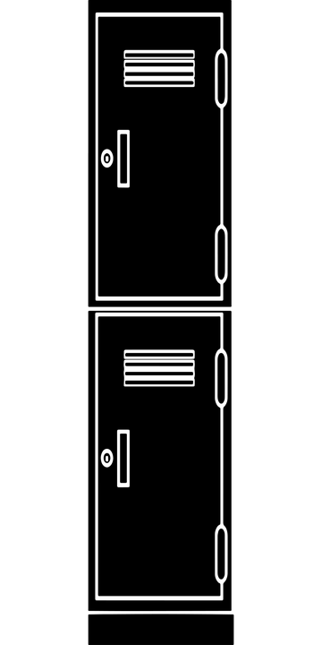Students will be assigned their locker and combination. They will have time to practice unlocking their lockers, too!
  - Students will receive their class schedules. They will be able to walk the building and find where their classes are located.

School & Internet Safety Programs/Presentations at SMS:
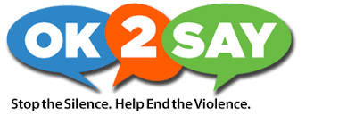
School safety is a top priority here at SMS. We work hard to partner with parents and students to maintain open lines of communication in order to be as proactive as possible. Please, if you have a concern or hear of something concerning, SAY SOMETHING. To help educate students and families with strategies to address concerns related to students’ safety, we have already begun planning for two presentations your child will have the opportunity to participate in this coming school year. We will be communicating the dates of these presentations when they are confirmed. The presentations we are planning will be conducted by OK2Say and Protect Young Eyes. You can find in-depth information about each of these presentations at the link below.

OK2SAY
Protect Young Eyes Parent Resources

SMS Recommended Supply Lists:
Content Area | Recommended Supplies
English/Language Arts | -A binder with pockets, used only for this class (or a folder with pockets and fasteners for paper)  -A notebook for writing, used only for this class  -Pencils and pens with blue or black ink  -Headphones or earbuds to use with audio text  -Novels for independent reading. They should be a little above your current reading level. They can be from the library, or you can buy or borrow them somewhere else. During the first week of school, we will talk about how to select the right novels and how to get them.
Mathematics | A 1.5 inch binder  Divider tabs (optional)  Spiral notebook or loose-leaf lined paper  Pencils  Erasers (cap erasers preferred)  Jumbo stretch book cover  A highlighter
Social Studies | 3 Ring Binder  2 Spiral Bound Notebooks  Pencils/Colored Pencils  Highlighters  Headphones/Earbuds for school only
Science | Your student’s Science teacher will provide a list of needed materials during the first days of school.
Art | Pencils/Colored Pencils  Markers
Band | Pencils  1 inch 3-ring binder with pockets  Instrument  Method Book “Measures of Success”:  -6th grade uses Book 1, 7th Grade uses Book 2  -We will be taking orders for these during the first week of school, but if you would like to purchase the book ahead of time, it can be found on Amazon.  Metronome/Tuner:  -May also use an app for this (we recommend Bandmate or Tonal Energy for tuning, and any free metronome app is fine).  Woodwinds: reeds (visit https://spartamiddleschoolmusic.weebly.com for specific brand and strength recommendations), cleaning swab  Brass: valve or slide oil, tuning slide grease, mouthpiece  Percussion: Vic Firth SD-1 General drum sticks, practice pad. Students may purchase their own mallets, but it is not required.
*Please note it is not a requirement that your son/daughter arrive with these materials on the first day of school. However, if you are able to provide them with these items it would be greatly appreciated.
Updating Your Powerschool Information:
As part of our ongoing efforts to be supportive of you and your child, it is essential that we have up-to-date, accurate information in our PowerSchool pupil accounting system. This information provides us with your consent to have your student use computers here at school, attend field trips and also important privacy concerns. Most importantly, it ensures that in the event we need to contact you in a timely manner we have the correct contact information.
We have provided you with instructions on the following page to help you complete this update. Please call our office at your convenience if you have questions. We would be happy to support however we can.
Directions to Update PowerSchool Student Information:
- Log In to PowerSchool
- Select the Demographic Tab
- Work through each section, completing and updating each portion as needed
- *Please be sure to work your way through to the FORMS section. This is the section where you provide your permission/consent for important school related functions.
*Please be aware that you will be unable to update your PowerSchool information until student schedules are released in August and parents are granted access.*
Sparta Education Foundation (SEF) Events Calendar for 19-20: “Providing Extras for Education”

Mark your calendars for our upcoming fundraisers:

SEF Pasta Night
Monday, February 3, 2020, 4-7:30 p.m.
The Garden Patch Restaurant 125 N. State St. in Sparta

RetroBowl
Saturday, March 14, 2020, 9:30 a.m. and noon bowling times
(sponsors welcomed and encouraged)
Sparta Lanes 125 N. State St. in Sparta

Have a wonderful summer!

