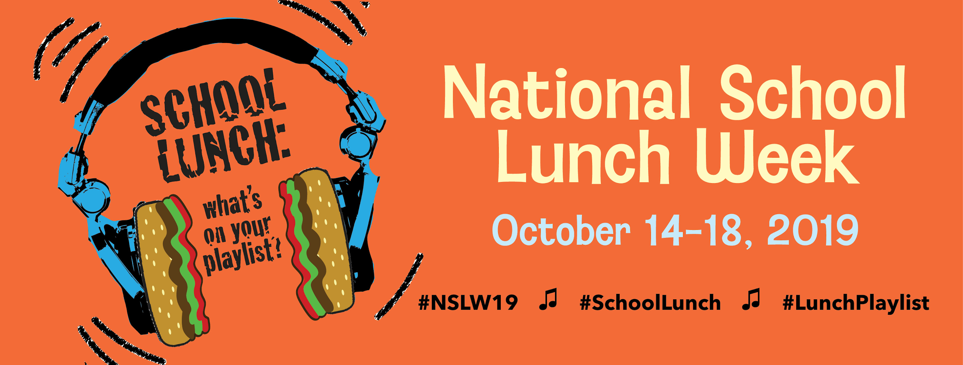

To recognize the National School Lunch Program, serving 30 million children each day, Sparta Area Schools will Celebrate National School Lunch Week throughout the Month of October. The theme, “School Lunch: What’s on Your Playlist,” spotlights how today’s school cafeterias are serving up healthy menu items that kids want to eat, with increased choice and customization.

National School Lunch Week highlights the nutritious foods available daily at Sparta Area Schools. Our planned activities will be as follows;

APPLEVIEW ELEMENTARY: Chef Table featuring our “Berry” Sweet Fruit Pizza Crackers. We will also be running a Creative Menu Naming contest. Students will have the opportunity to create new music-themed menu names. The contest will start Tuesday October 15th and will run until Thursday October 31st. On Friday November 1st students and staff will vote on their favorite music themed menu names. Winning names will be featured on the next menu cycle along with the winners receiving a prize.

RIDGEVIEW ELEMENTARY: Chef Table featuring our “Berry” Sweet Fruit Pizza Crackers on Wednesday October 16th. We will also be having a coloring contest. Students will have the opportunity to complete a coloring sheet, have it featured in the cafe and then on Friday November 1st winners will be chosen to receive a prize.

SPARTA MIDDLE SCHOOL: Chef Table featuring our “Berry” Sweet Fruit Pizza Crackers. Guess that fruit or vegetable blind-folded taste testing contest. Student winners will receive a prize. This contest and Chef table will be held during all lunches on Monday October 21st.

SPARTA HIGH SCHOOL: Chef Table featuring our “Berry” Sweet Fruit Pizza Crackers. Jeopardy Food & Nutrition. Winners will receive a prize. The contest and Chef table will be held during all lunches on Wednesday October 23rd.

“School lunches offer students fruits and vegetables, whole grains, and milk, and meet federal nutrition standards limiting fat, calories and sodium,” said Melissa Alley, Food Service Director. “National School Lunch Week helps educate parents and students about all the benefits of our lunch program and the appealing variety of choices in the cafe.”

October is also farm to school month. Please enjoy some of our locally grown produce during breakfast and lunch. Some of the items we are featuring this month include; Apples, Pears, Plums, Sweet Cherries, Blueberries, Rainbow Carrots, Broccoli, Frozen Mixed Veggies, Zucchini, Butternut Squash. Some of the local farmers we work with are Friske Orchards, Gavin Orchards, Second Spring Farm, Farm to Freezer, and Arbre Farms.

The federally-funded National School Lunch Program has been fueling students for success for more than 70 years. Elementary students can enjoy the convenience of a healthy school lunch for just $2.75 and Secondary students meals cost $2.90-$3.30. Some students may qualify for free or reduced priced meals ($.40). Contact Melissa Alley to learn more.

For more information about National School Lunch Month (October) please visit the Sparta Area Schools district website under the food service link. You can also reach out to the food service director Melissa Alley at melissa.alley@spartaschools.org or 616-887-1744. This institution is an equal opportunity provider.

Thank you
Melissa Alley

