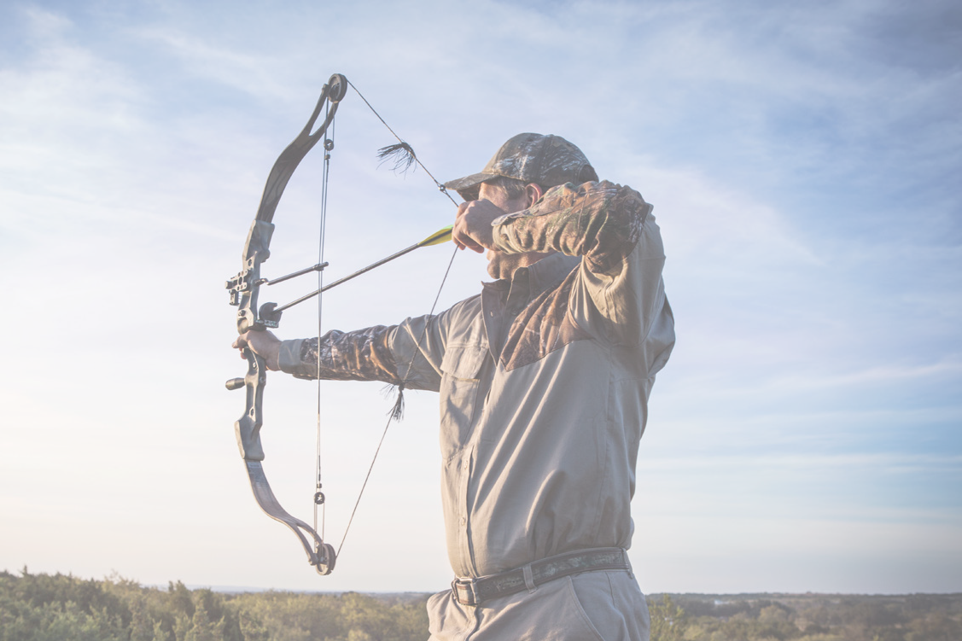Give Archery a

Try!

Have you ever wanted to try your hand at Archery? Now is your chance! Come for a half hour shooting session at West Michigan Archery Center on October 14, 2023. Sign up for a time slot, or just come to the club between 12 noon and 3:30 pm. **Shoot for free!**

**Must be 10 years old or older to shoot.**

Register for a time slot here:

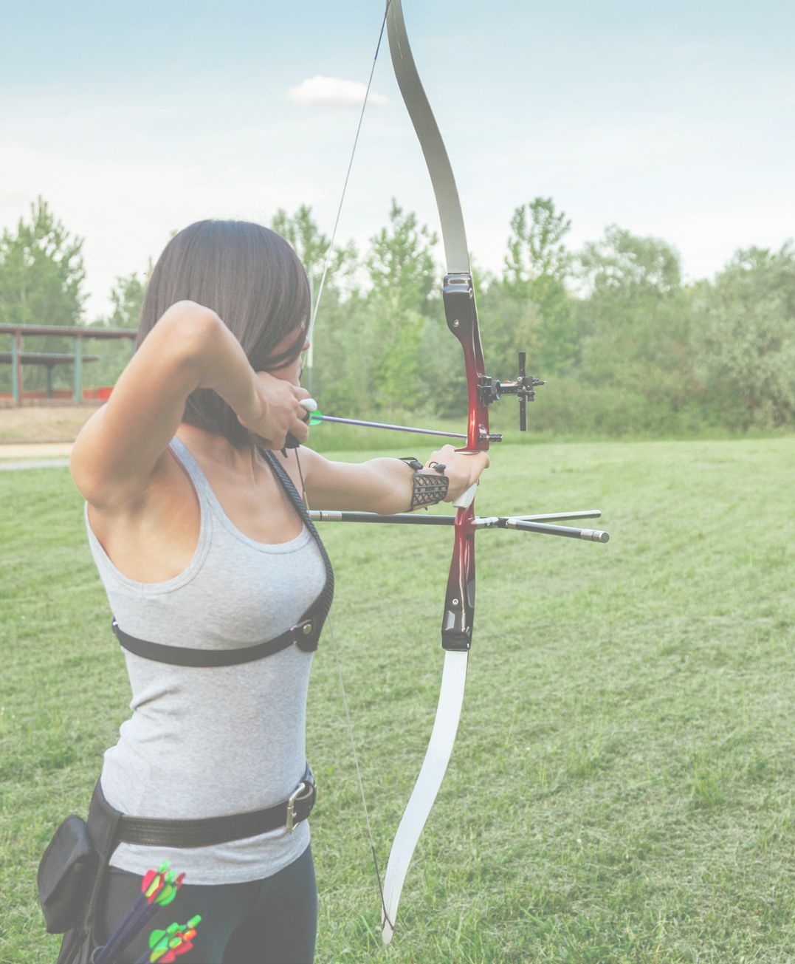

Or come to West Michigan Archery Center and shoot at the first available time slot!

[**Click here to register!**](https://westmichiganarchery.ccbchurch.com/goto/forms/65/responses/new)

West Michigan Archery Center 3500 10 Mile Road NE Rockford, MI

Questions? Contact Liz at: [eginebaugh@comcast.net](mailto:eginebaugh@comcast.net)

[https://www.westmichiganarchery.com/](http://www.westmichiganarchery.com/)

**WMACInc.**

**West Michigan Archery Center**