SPARTA HIGH SCHOOL

Home of the Spartans

SHS UPDATE 25: April 21, 2017

**SHS CULTURE**

* **Spartans Shine!:**
  + Seniors Carter Ferguson and Ryan Oldenburg were selected to the 2nd annual Addix All-Star High School Football team. This all-star game will be on June 9 at Davenport University. According to the website of the group organizing the event: *This event was created to celebrate Grand Rapids area football and to unite the greater Grand Rapids community to bring awareness to Gilda's Club Grand Rapids.  Gilda's Club is an amazing organization that provides free cancer and grief support services to individuals and families dealing with life's "tough stuff".  In its first year the event had over 2,500 attendees, 100 student athletes representing 40 schools, and raised $20,000 for Gilda's Club.(*[*www.addixgear.com*](http://www.addixgear.com) *)* For ticket information please visit the aforementioned website.
  + Ben Sheckler (SHS Class of 2013) pitches in the San Diego Padres’ organization. On Wednesday, April 19 Ben was the winner pitcher against The West Michigan White Caps. For more information on Ben’s win, [CLICK HERE!](http://woodtv.com/2017/04/19/spartas-sheckler-helps-tincaps-beat-whitecaps/)
  + Senior Nick Robbins won this week’s [WZZM Meijer Scholar Athlete of the Week award](http://www.wzzm13.com/sports/high-school/scholar-athlete/meijer-scholar-athlete-nate-robbins/432576796)! Way to go, Nate!
* **Best Prom Ever:** Sparta High School will host the nationally recognized Best Prom Ever on Saturday, April 22. Over 1,000 people with disabilities will enjoy a formal dinner and dance experience. A special thanks to Teacher of the Year Renne’ Wyman, and her program, for putting on this wonderful event.
* **Spartan Values:** Spartan Value for the month of April is Trust.
* **Safe and Sober Prom Season:** Please communicate with your student(s) about the importance of safety and sound decision making during prom season:
* Plan proactively for curfews
* Check-in on the night prom and know where your student is planning to go
* Create an “opt out” plan in case your son or daughter finds himself/herself in a situation they need to leave.
* Discuss the ramifications of partying (safety, legal issues, athletic suspensions)

It is illegal to supply alcohol or a safe-haven to consume alcohol to minors.

**SHS CURRICULUM**

* **Spring Assessment:** The administration of the SAT/Work Keys/MSTEP exams is almost complete. Make-up tests dates are April 25 and 26. Michigan high schools are “graded” by the number of students that complete these assessments, as well as how well our students perform compared to other schools. Students use the results of the SAT for scholarship opportunities and college entrance. Work Keys results provide information about students’ aptitudes and career readiness. The successful completion of these exams is a graduation requirement.
* **Professional Learning Communities (PLCs):** Our academic departments (PLCs) meet for 120 minutes a month (minimally) to collaboratively discuss, and analyze, curriculum, pacing, and student performance.
* **Nicole Vagle**: One of the world’s leading voices in Curriculum and Assessment will visit Sparta High School on May 19 to train and work with our PLCs. Ms. Vagle’s most recognizable work is her book *Design in 5: Essential Phases to Create Engaging Assessment Practice*. The follow topics will be covered during her visit:
* Balance Assessment Philosophy: Balancing the importance of daily tasks, unit tests, and standardized assessments.
* Grading and Homework Practices.
* The 6 steps to quality curriculum alignment and assessment
* For more information on her work: [Click Here!](http://allthingsassessment.info/author/nicole-vagle/)

**SHS COMMUNICATION**

* **VOLUNTEERS NEEDED!:** On the morning of May 19, 7:20 – 10:40 (arrival time 7:00), the freshman students will participate in an event called Life Unplugged. It is an activity designed to have them experience real life financial consequences based on their chosen careers and life choices. It is a real “eye-opener” for many students and therefore a great life lesson.

Many volunteers are required to make this a success. It is very easy to help, as all the information you need will be given to you and staff will be there to answer any questions you may have. The only real experience required is to have lived and managed money. It is a good time as well! Every volunteer that has helped in the past have expressed how interesting and fun it was to watch the kids as they realize just how expensive life can be!

Please consider joining us! Feel free to ask a friend to work with you! You do not need to have a freshman student to volunteer. Grandparents and “Grandfriends” are most welcome. If you are able to help for all or most of the time please email [ruth.bradford@spartaschools.org](mailto:ruth.bradford@spartaschools.org). We need to have your answer as soon as possible. We am hoping to get about 40 volunteers.

* **Advanced Placement Testing Schedule:**

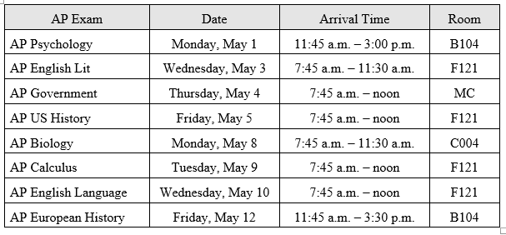

* **A look ahead at the Calendar**:

Saturday, April 22: Best Prom Ever 5:00 – 10:00 pm at SHS

Saturday, April 29: Sparta High School Prom 7:30 -10:30 at St. George’s

Friday, May 19:  Half day for students, professional development for staff

Tuesday, May 23:  Senior Awards Night @ 7:00 pm in the Auditorium

Senior/Early Exam Window: May 25 (periods 1, 3, and 5) and 26 (periods 2, 4, and 6).

Friday, May 26:  Last day for seniors.

Thursday, June 1:  Commencement @ 7:00 pm in the Gymnasium

Thursday, June 8:  Half day for students, professional development for staff

Friday, June 9: Half day for students, last day of school