SPARTA HIGH SCHOOL

Home of the Spartans

April 14, 2017

* **School Improvement**: *On an annual basis, our School Improvement Team is required by the State of Michigan to create measurable goals and action plans tied to student performance on State assessments, school culture, and building protocols.  In addition, we are required to review our goals and progress each year by analyzing our results with input from students, parents, and staff.  This year our team has organized our goals and action plans for the 2017-18 school year in into the following categories:  CULTURE, CURRICULUM, AND COMMUNICATION (C.C.C.).  I plan on modeling the use of the C.C.C mantra, as well as the making direct connection of our professional behavior to those categories*

**CULTURE**

* **Spartans Shine!:** Over Spring Break, Senior Natalie Wright and her Grand Rapids Pacer teammates won the [National Championship](http://www.wzzm13.com/sports/junior-pacers-bring-home-championship/427969895) in basketball for their respective division. Next fall, Natalie will continue her education, and her basketball, at the University of Illinois.



* **Honoring Retirees:** Sparta High School is losing of 100 years of service with the retirement of Karen Bosscher (Guidance Secretary),  Denise Colon-Bonet (Spanish Teacher), Julie Mengel (Special Ed Teaching Assistant), and Tom Lutke (Art and Biology Teacher).  Sparta High School would like to recognize the important work that these professionals have provided.  Please thank these wonderful Spartans!

Karen Bosscher:          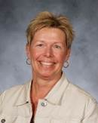

Place of birth: Grand Rapids, MI

High School: Grand Rapids Union High School

Years of Service:  to Sparta Area Schools: 23 years

Position(s) you have held: Guidance Secretary

Spouse: David

Children: Peter, Marketing at Site One Landscaping Supply; Robyn, District Manager for Regis Corporation; Jodi, Professional Photographer

Grand-Children: 6 boys; Hunter 13, Dustin 10, Nolan 6, Kolten 4, Ezra 4, Kooper 1

What you like to do away from work: walk, scrapbook, crochet, garden, read, travel

Retirement Plans: build a new house, walk, scrapbook, crochet, garden, read, travel

Denise Colon-Bonet:        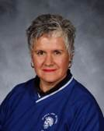

Place of birth: Des Plaines, Ill

2. High School: Lakeview MI

3.  Years of Service to Sparta Area Schools: 22

4. Position(s) you have held. Spanish Teacher

5.  Spouse: Raymond Waite

6:  Children (and brief explanation of what they are doing) 1 daughter currently serving as an officer in the US Navy in Japan and Pacific Rim.

7:  Grand Children /none

8:  What you like to do away from work: I  ride horses and play with my dogs, write, read, go on mini-adventures with my husband.

9:  Retirement Plans: Visit Japan, the Netherlands and Spain.  Ride as much as I can.  Learn new things.

Julie Mengel: 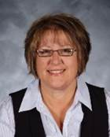

Place of birth:  Grand Rapids Michigan

High School:  Sparta High School

Years of Service to Sparta Area Schools:  26

Position(s) you have held:  1st - 4th grade Title 1/Chapter 1 aide for 14 years, High School ISS room and Special education aide 12 years

Spouse:  Ron

Children:  Son Ryan is married and living in Kenosha Wisconsin.  He is a Central Processing Technician at a MedSurg Center,  Tyson is married and is also living in Kenosha Wisconsin.  He is a teacher and head Varisty football coach.

Grand Children: 1 granddaughter, Delia

What you like to do away from work:  I enjoy quilting, and upcycling old furniture.  I also enjoy reading, and gardening.

Retirement Plans:  I am looking forward to that first snow day.  Not getting that call.

Our future plans has us moving to Kenosha to be with our boys and their families.

Thomas Lutke:  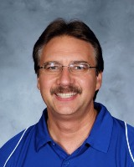

Place of birth: Blodgett Hospital in Grand Rapids, MI....grew up in Wyoming  Park area

High School: Rogers HS in Wyoming

Years of Service to Sparta Area Schools: 25 years (plus 7 in non-public education K-8)

Position(s) you have held: Art teacher, Biology teacher, PE teacher, AMPE District Chair, AMPE HS Chair,  District PD Trainer with Mark Kasmer, SI member, Content Literacy Team member, HS Attendance committee member, Biology/Science PLC team

Spouse: Joni Lutke 37 years and counting....8^)

Children: (and brief explanation of what they are doing):

**\*Pete Lutke** (SHS 2001): Graduated from Ferris State University with Bachelor's Degree in Digitial Animation and Game Design....currently living in Northridge, CA...working as a freelance Computer Graphics Artist...dating a nice young lady from his church

**\*Anne (Lutke) Healey** (SHS 2003): Graduated from Eastern Michigan University with Bachelor's Degree in English/Language Arts...taught ELA in Bakersville, CA; Shanghai, China; and Tampa, FL....currently living in suburb of Tampa with husband Dave Healey...both are teachers (Dave MS/HS Math)...expecting first child in August

Grand-Children: #1 on the way!!!  8^)

What you like to do away from work: Archery/Bowhunting are primary hobbies....along with some fishing in the summertime

Retirement Plans: Permanent part-time Pastor at County Line Community Church, NW of Coopersville since August of 2017...planning to move to the parsonage mid-summer and invest my efforts at the church...believe that Education is the second most important job in the world...where one ends up for eternity is number ONE.

**COMMUNICATION**

* **Construction Update (Repeat):** Heavy equipment arrived at Sparta High School on Tuesday, and dirt will be moving soon! We are hopeful that the work on our softball, baseball, track, football and marching band facilities will begin the Week of April 3. During the construction phase, the lot behind Sparta High School and the rear entrances to the building will NOT BE ACCESSIBLE.

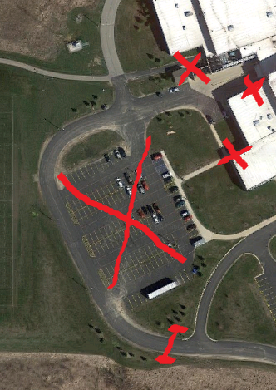

* **A look ahead at the Calendar**:

Tuesday, April 18: MSTEP Science exam for juniors (Taken in Civics/Econ class)

Thursday, April 20: MSTEP Social Studies for juniors (Taken in Civics/Econ class)

Friday, May 19:  Half day for students, professional development for staff

Tuesday, May 23:  Senior Awards Night @ 7:00 pm in the Auditorium

Friday, May 26:  Last day for Seniors.

Thursday, June 1:  Commencement @ 7:00 pm in the Gymnasium

Thursday, June 8:  Half day for students, professional development for staff

Friday, June 9: Half day for students, last day of school